**IOANNIS STERMOUGKOU**

**ELECTRICIAN**

[ **themanmove1@outlook.com** Ó **+306982072281**

**Kauppakartanonkatu 10 K 128 00930 Helsinki Finland**  **17 December 1990**

# EDUCATION

**EPAS GREECE**

June/2011

• Electrician Technician

# EMPLOYMENT HISTORY

ELECTRICIAN. NH Bemanning AS. 15/01/2024 – 12/04/2024. Odda.

Installation of earthing cables and metal bridges, copper bars

——————————————————————————————————

ELECTRICIAN

Kyron. Sahko. Oy

01/02/2023 – 01/06/2023

Installation of metal bridge, kNX , lights and switches

——————————————————————————————————

Electrician

**ELEKTROTIENSEN AS**

July/2022 – August/2022 Oslo

• Removal of old cables, fire alarm (smoke detectors ) boxes on bridges 230v + 24v, KNX, Flash, Emergency Light, plastic canals

——————————————————————————————————

Electrician

**E HALVORSEN ELEKTRO**

January/2022 – June/2022 Alta Norway

* installing of Fire Alarms ( smoke detectors ) , Flash, Emergency lights ,KNX cabling, metal bridges, Empty pipes and cabling
* —————————————————————————————————

Electrician

**Mploy AS**

January/2018 – July/2020 Oslo

* have been working in various positions such as Pulling empty pipe, pulling cables, installing boxes and switches, lights and others electrical appliances

# REFERENCES

MPLOY AS . Christian Mohe - +47 45127703

E HALVORSEN ELECTRO AS ( Kjetil kvernme ) project leader - +47 948 11 229

ELEKROTJENSEN AS ( Mohe ) project leader - +47 468 98 482

# CERTIFICATES

DSB

**Norwegian Electrical Institution**

2020

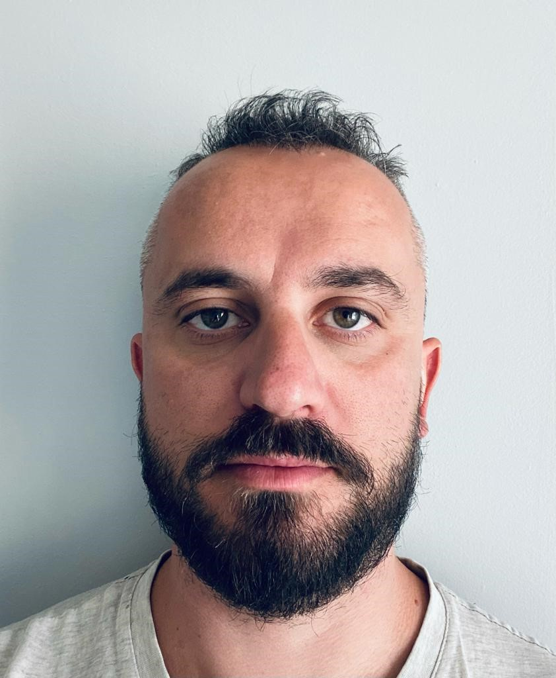

# SUMMARY

*I am an hard working person, well organised and team working, i always like to envelop and develop my self . Also always willing to learn new skills.*

# SKILLS

Electrical Installations and maintenance

# HOBBIES

Movies,walkingout,lovemusic,

# LANGUAGE SKILLS

|  |  |
| --- | --- |
| **GREEK** | ○○○○○○ |
| **ALBANIAN** | ○○○○○○ |
| **ENGLISH** | ○○○○○○ |

# OTHER

Drivers License: B

Marital Status: in a relationship

DIPLOMA

**EPAS GREECE**

2011